EXP NO 13: Create a Virtual Machine with 1 CPU, 2 GB RAM, and 15 GB Storage Using VMware Workstation

AIM:
To create a Virtual Machine with 1 CPU, 2 GB RAM, and 15 GB storage disk using VMware Workstation (Type-2 Hypervisor).
- RAM: 1 GB
- Hard Disk: 15 GB
- Processors: 2

PROCEDURE:
- Open VMware Workstation.
- Click Create a New Virtual Machine.
- Select Typical (Recommended) and click Next.
- Browse and select the Ubuntu ISO file.
- Select Linux → Ubuntu (64-bit) as the guest operating system.
- Enter the virtual machine name and choose the storage location.
- Set the virtual hard disk size to 15 GB.
- Click Customize Hardware.
- Set Memory = 2048 MB (2 GB).
- Set Processors = 1 Processor (1 Core).
- Click Finish to create the virtual machine.

1.SELECTING MEMORY DATA(GB):

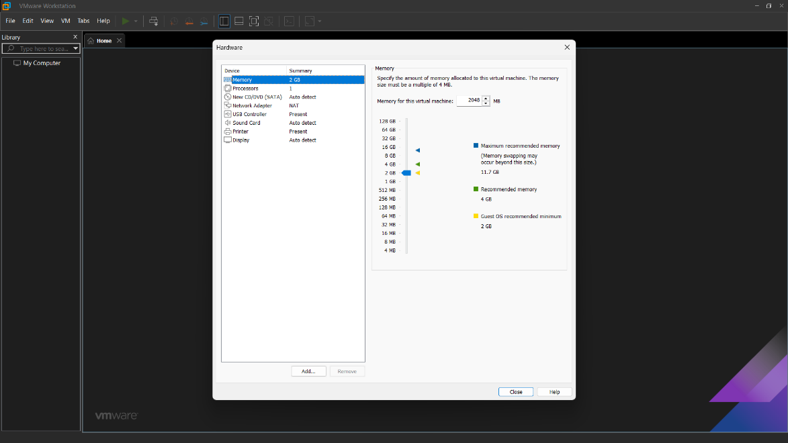

2.SELECTING NO. OF PROCESSORS:

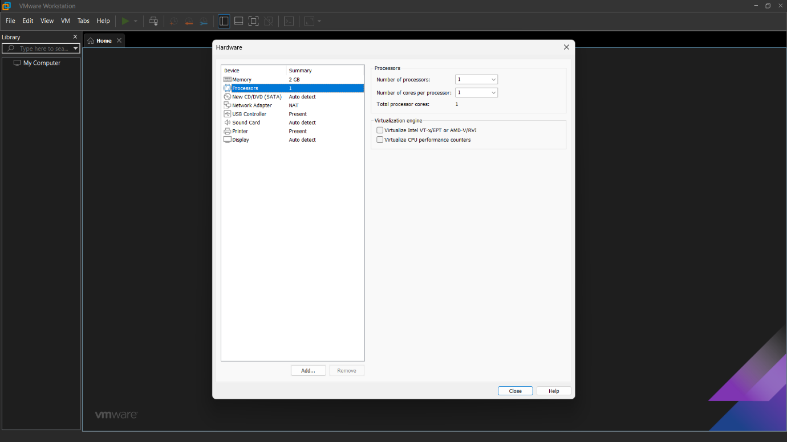

3.SETTING OF HARD DISK DATA(GB):

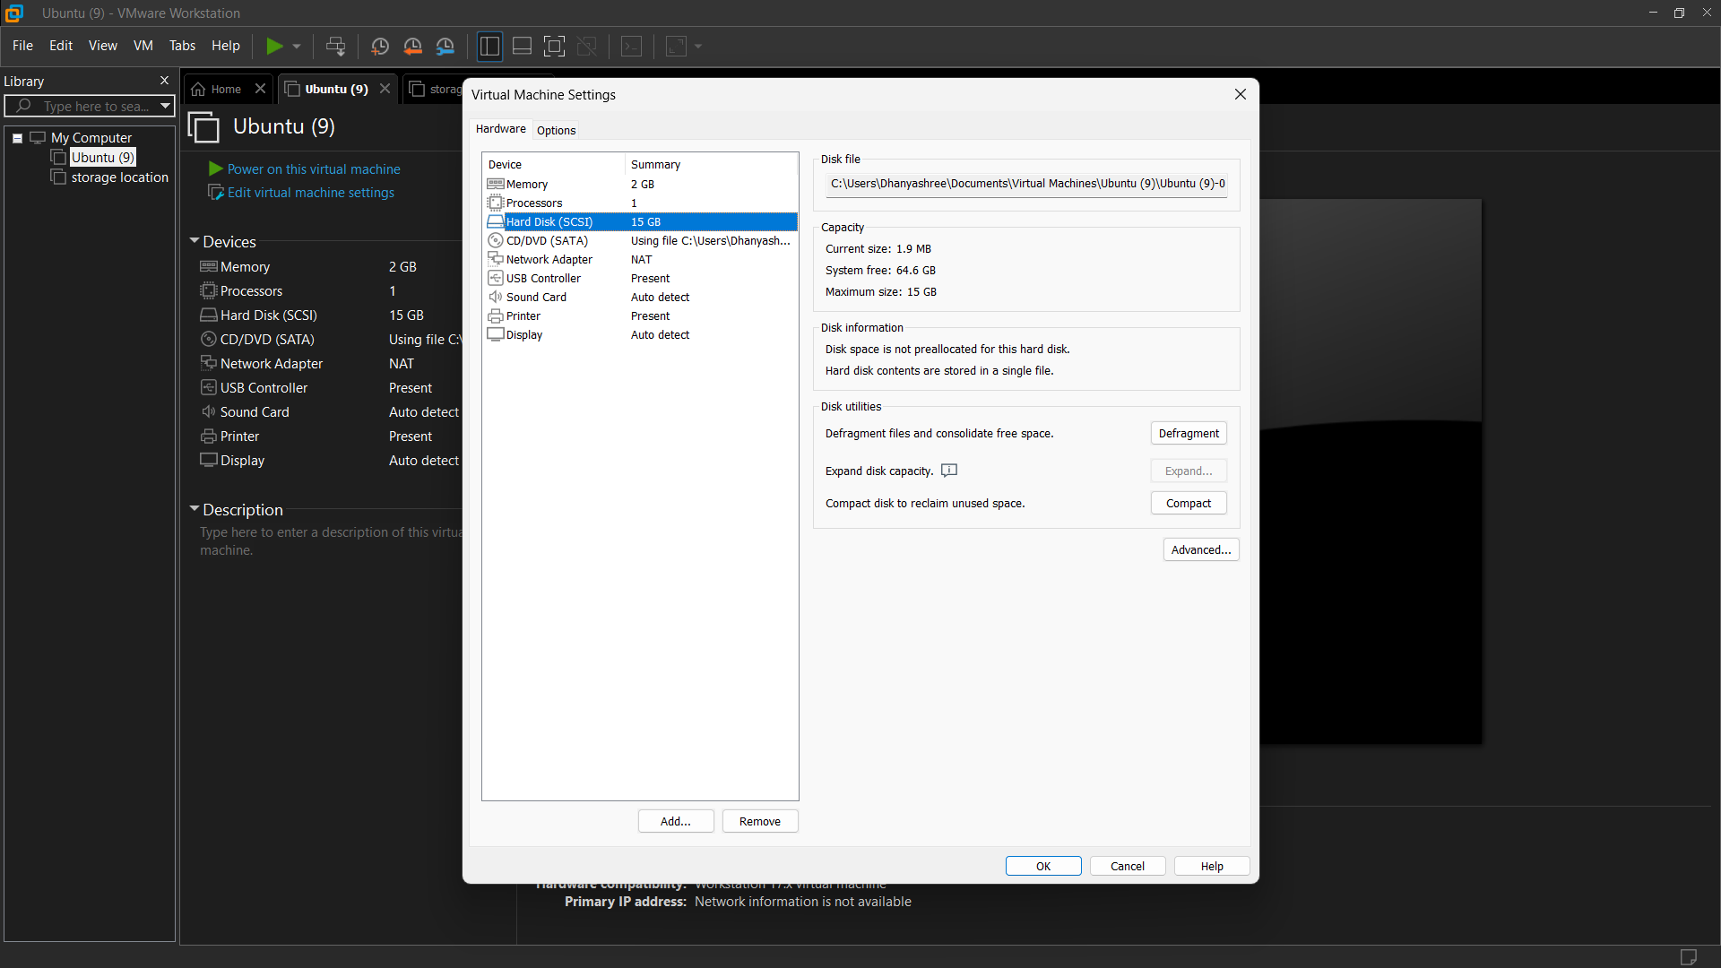

3. UPLOADING THE UBUNTU:
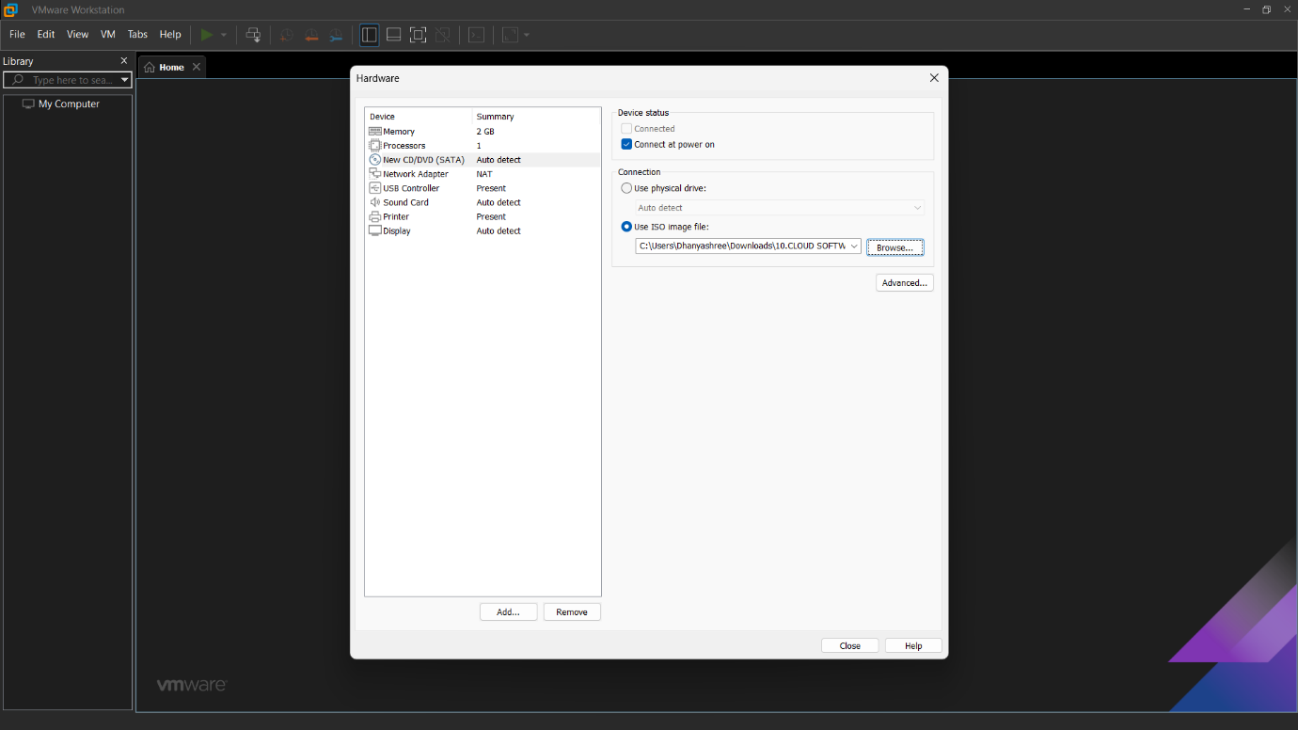

OUTPUT:

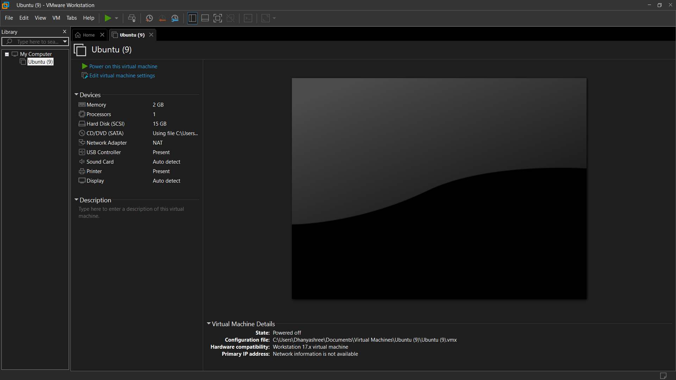

RESULT:
A Virtual Machine was successfully created using VMware Workstation (Type-2 Hypervisor) with 1 CPU, 2 GB RAM, and 15 GB virtual storage, and Ubuntu was installed successfully.

